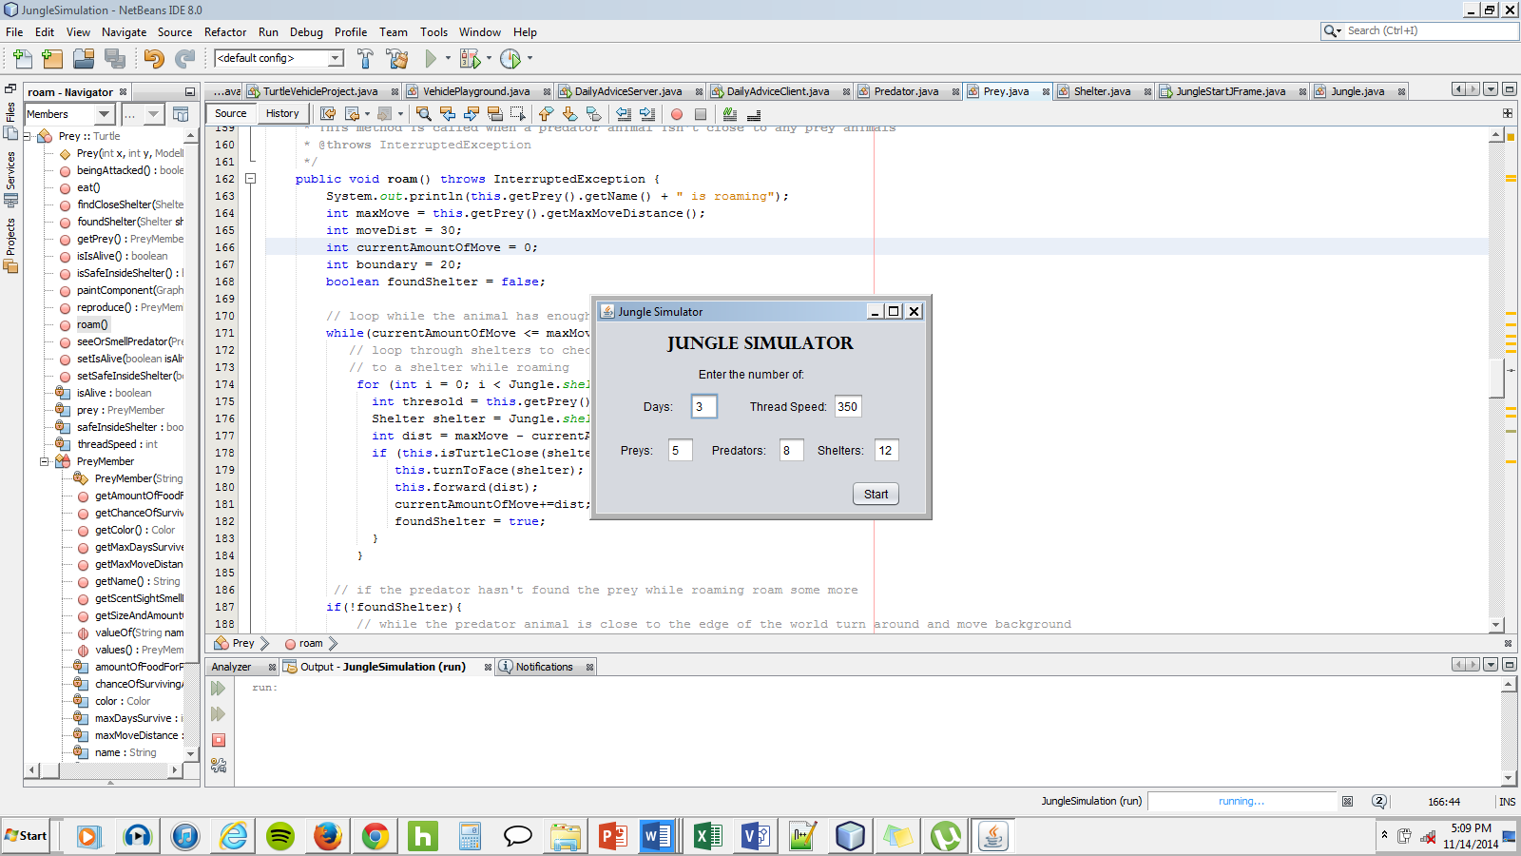

1. Either enter new numbers or leave default numbers in text fields and click start (entering high numbers causes a java.util.ConcurrentModificationException)
   1. There isn’t any input validation so **only** enter numbers between 0 and around 34 for the prey, predators, and shelter textfields.
   2. The Days text field doesn’t really do anything
2. After clicking start a world should appear and look similar to this:

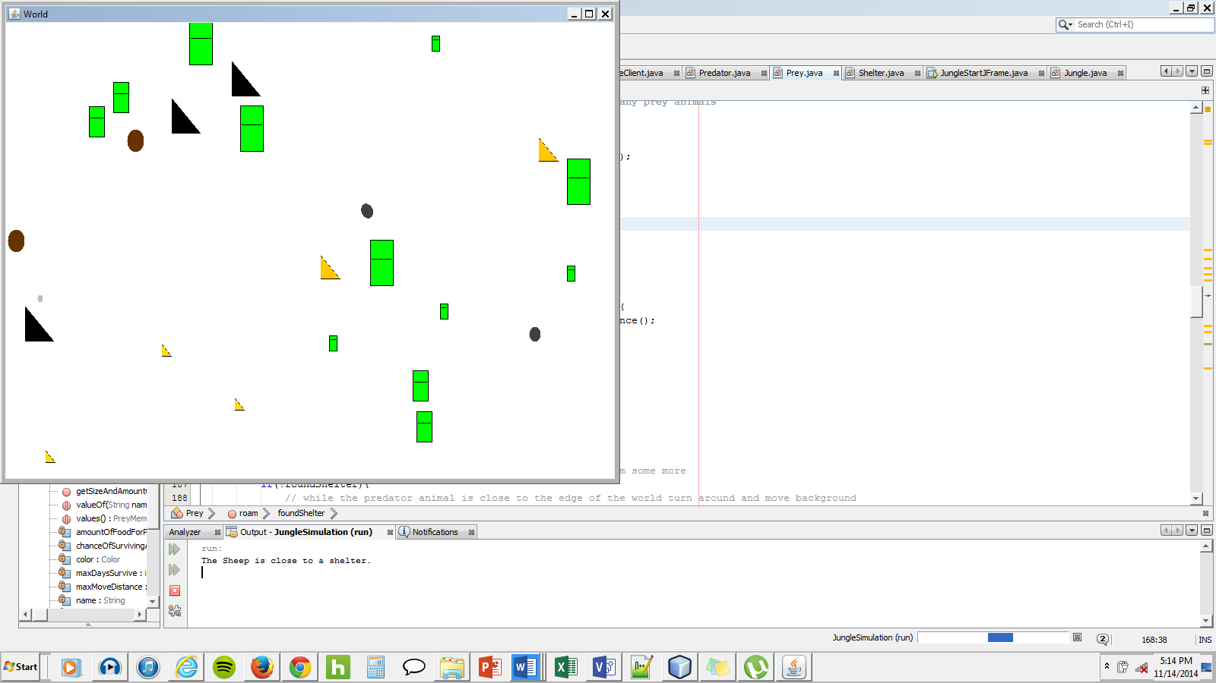

1. These represent shelters for the prey animals to hide in
2. These represent prey animals (different colors and sizes for different types)
3. These represent predator animals (different colors and sizes for different types)
4. Depending on the numbers entered in the GUI determine how many different prey animals, predator animals, and shelters appear randomly throughout the world
5. During all of this the console is printing out information about the current moving prey or predator animal:
   1. First, all of the prey animals one at a time will move toward a close shelter if the shelter is within its movement range. If the prey animal can fit inside the shelter the prey animal icon will become invisible. If no shelter is close to prey animal will move around randomly.
   2. Next, all of the predator animals one at a time will move toward a close prey animal if the prey animal is within its movement range. If the predator is close enough it will attack the prey animal but the prey animal will have a chance of surviving the attack. If the attack is successful the prey animal icon becomes invisible. If no prey animal is close to the predator animal will move around randomly to attempt to get closer to a prey animal.